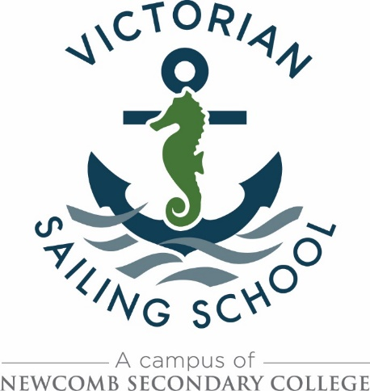

**Sample Itinerary**

The following itinerary is to be regarded as a sample only. The actual program developed for each group will alter depending on:

* Arrival time on first day and each subsequent day (allowing for the fact that many schools from outside immediate Geelong area need to travel to Geelong either by School owned bus /Rented bus / Train*)
* The duration of the program booked, i.e. 2 days, 3 days, 2 groups from the same school over the course of a week with a change over during the Wednesday or 5 days
* The number of students in the group
* The subject area / elective / program in which sailing has been included from each Visiting School
* Weather – VSS staff thoroughly assess weather forecasts /predicted wind models /observations as they are available from the Bureau of Meteorology and other sources in making any decision regarding sailing#, with students safety, well-being and enjoyment of their sailing experience being paramount
* Departure time each day and / or at the completion of the program.

VSS staff work on the assumption that majority of students are novices i.e. no previous experience.

Likewise, there is NO expectation that Visiting Teachers complete any theoretical sailing work with their students beforehand.

Note - *should groups elect to travel to Geelong by train, VSS staff will meet the group to transport luggage from Geelong station to VSS…approximately 15 minute walk

#VSS has in place a “Strong Wind Policy” well within wind strength limitations set by

DEECD in the Safety in Outdoor Adventure Activities Guidelines and those recommended by

Yachting Australia. This policy can be seen at <http://sailingschool.vic.edu.au/programs.htm>

SAMPLE ITINERARY

**Day One**

9.00am Welcome. Theory session

10.30am Break

10.45am Rigging of boats on the beach

11.45am Break / Lunch / Change

1pm Sailing Session #1 – concentrating on:

· Launching

· Helming position and technique

· Crew position and basic sail trimming

· Balance

· Sailing around a “Reaching” course i.e. at, or close to, a true wind angle (TW) of 90 degrees to the wind

· Tacking i.e. turning the boat in a controlled manner upwind

2.30pm Return to the beach and de-rigging

3.00pm End of day

**Day Two**

9.00am Debrief Day One, Briefing Day Two

9.30am Change and rig boats

10.15am Sailing Session #2 – concentrating on:

· Consolidating skills learnt in Session #1

· More advanced sail trimming

· Introducing “Beating” i.e. sailing at a TW angle of between 60 and 45 degrees to the boats direction of travel, and “Broad Reaching” with a TW angle of between 120 and 135 degrees

· Gybing i.e. turning the boat in a controlled manner down wind

11.30am Lunch

12.30pm Sailing Session #3 – concentrating on:

· Consolidating skills learnt in Session #1 and #2

2.30pm Return to beach and pack up

3.00pm End of day

**Day Three**

9.00am Debrief Day Two, Briefing Day Three

9.30am Change and rig boats

10.15am Sailing Session #4 – concentrating on:

Consolidating skills of- Reaching, Beating, Broad Reaching, Tacking, Gybing in such a way that students are able to sail a triangular course

11.30am Lunch

12.30pm Departure for travelling school or sailing session #5 concentrating on EITHER:

· Racing (if the weather conditions and the level of the students skill development is such that racing can be conducted in controlled and safe manner, this can be considered an option to complete the program) OR

· Touring